**IMPORT INVOICES**

**Wharfage Estimation Invoice Steps**

1. Create Import General Manifest
2. Click on Import Estimation Invoice

* Select VCN Number
* Bill of ladings will display in actions Estimation Invoice icon is visible.

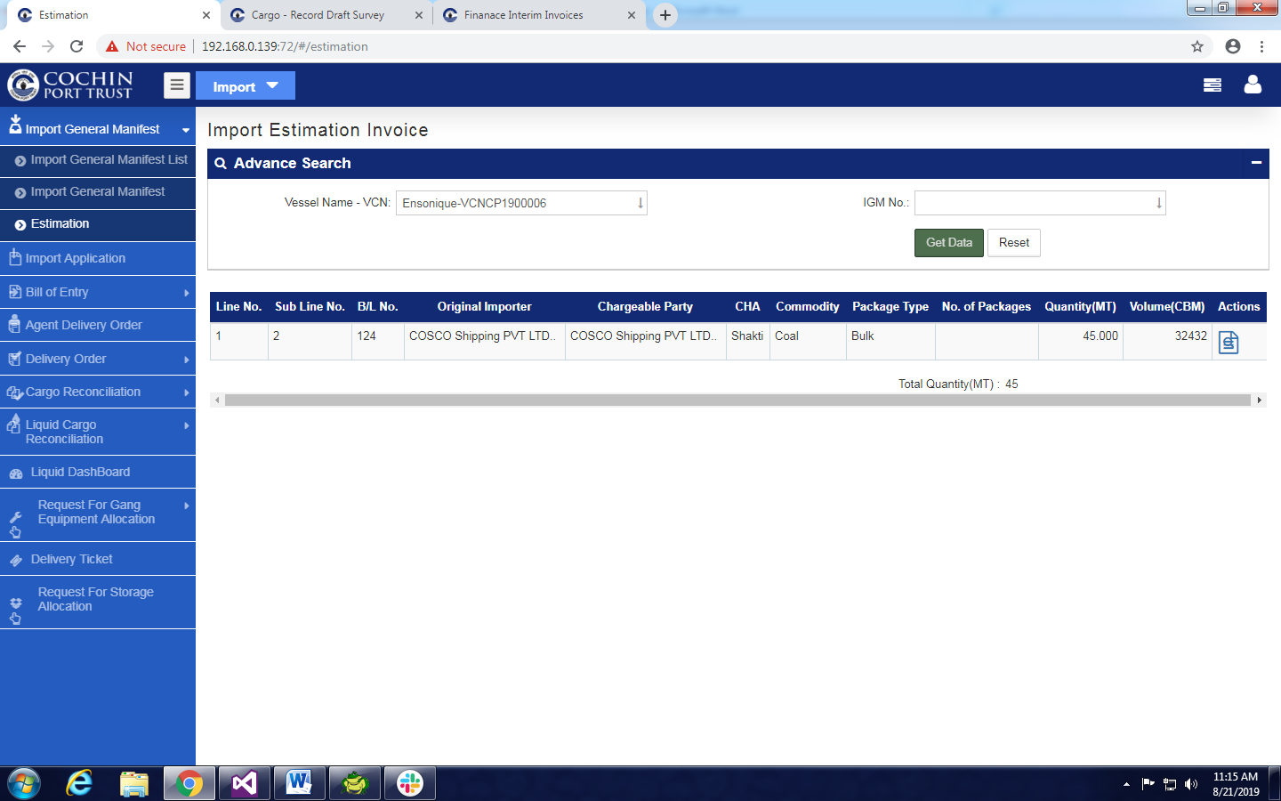

* Click on Estimation Invoice Icon .
* Wharfage Estimation Invoice is display.

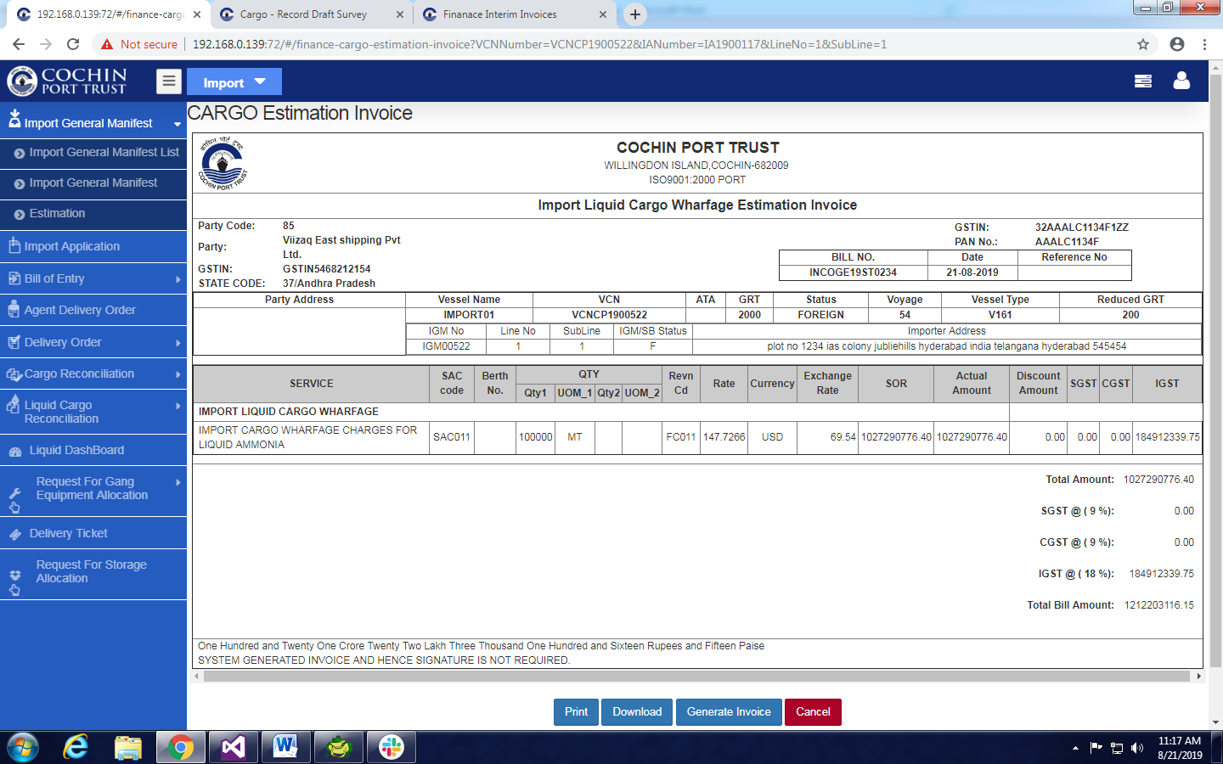

* Click on Generate Invoice Button Invoice will generate.

1. To View Estimation Invoice

* Click on Import Estimation Invoice
* Select VCN Number
* Bill of ladings will display in actions Estimation Invoice icon is visible.
* Click on Estimation Invoice Icon .
* Wharfage Estimation Invoice is display.

**Wharfage Invoice (Final Invoice)**

1. Open **Jetty Operations Module**
2. Click on **Tally Operations**

* Selec t **IMPORT** Radio Button
* Select VCN Number From Auto fill Suggestion.

1. Click on **Pre/Post Operation Times**.

* Click **Pre/Post Operation Times** Button.
* Fill Quantity in Line Items

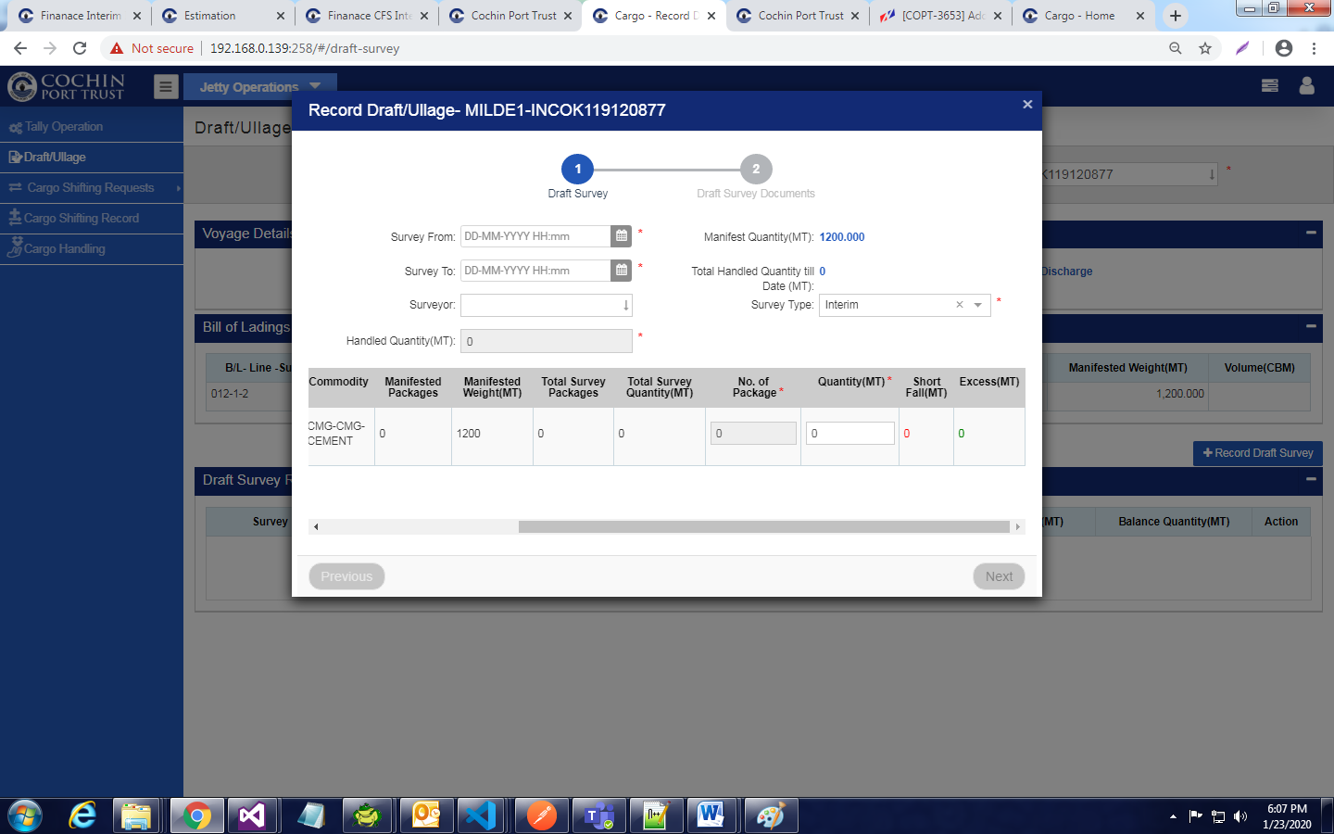

* Give All mandatory Data click on save button

1. Click on Vessel Operations tab

* Now Click on Record Vessel Cargo Operations.
* Provide all mandatory Data

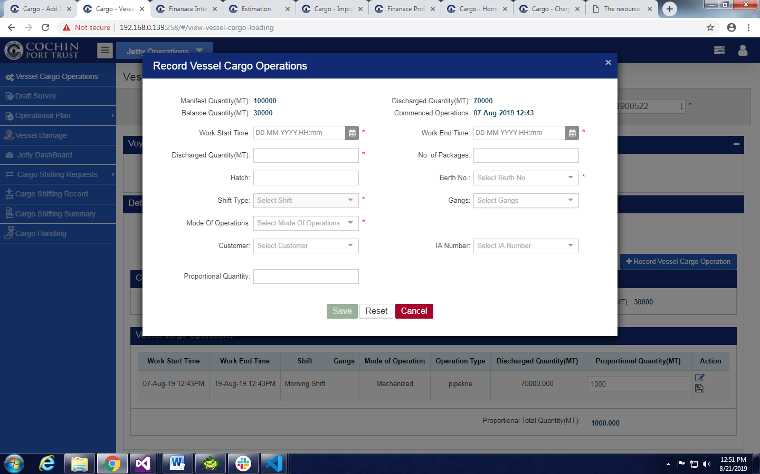

* Click on Save Button .

1. Click on Delays Tab

* Click on Record Delay button .
* Provide all mandatory Data

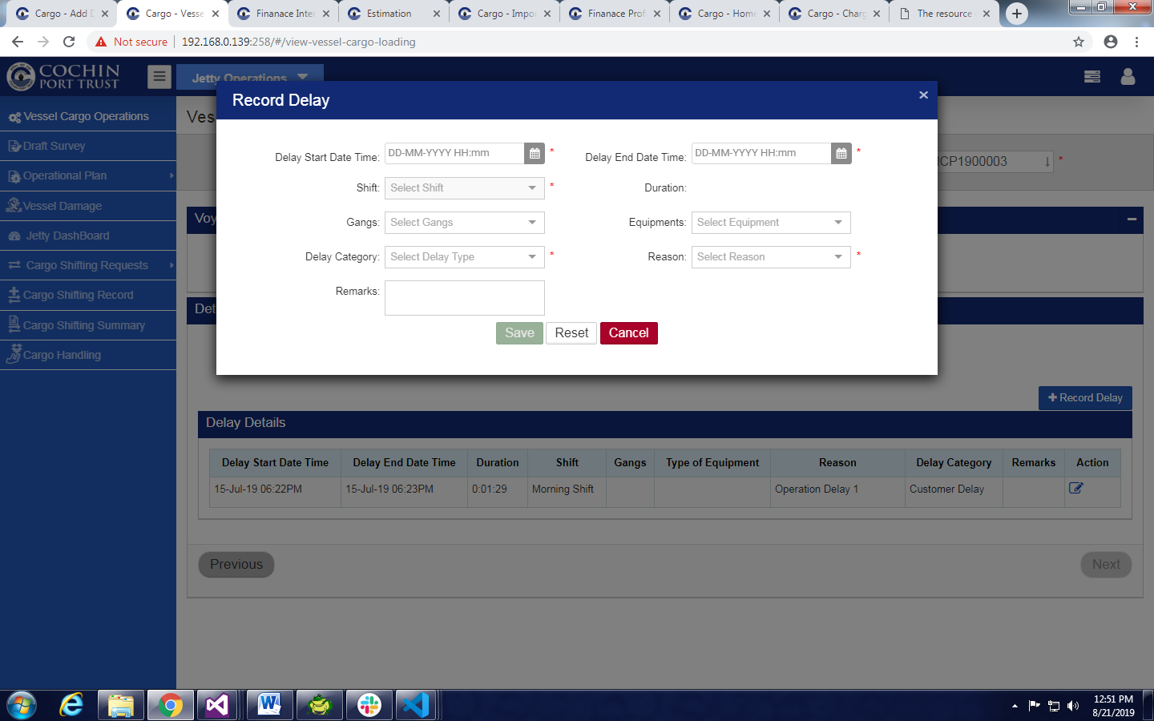

* Click on Save Button .

1. Click on **Draft /Ullage**

* Select VCN Number From Auto fill Suggestion.
* Click on **Record Draft Survey** button.
* Give Valid Data and Click on Next .

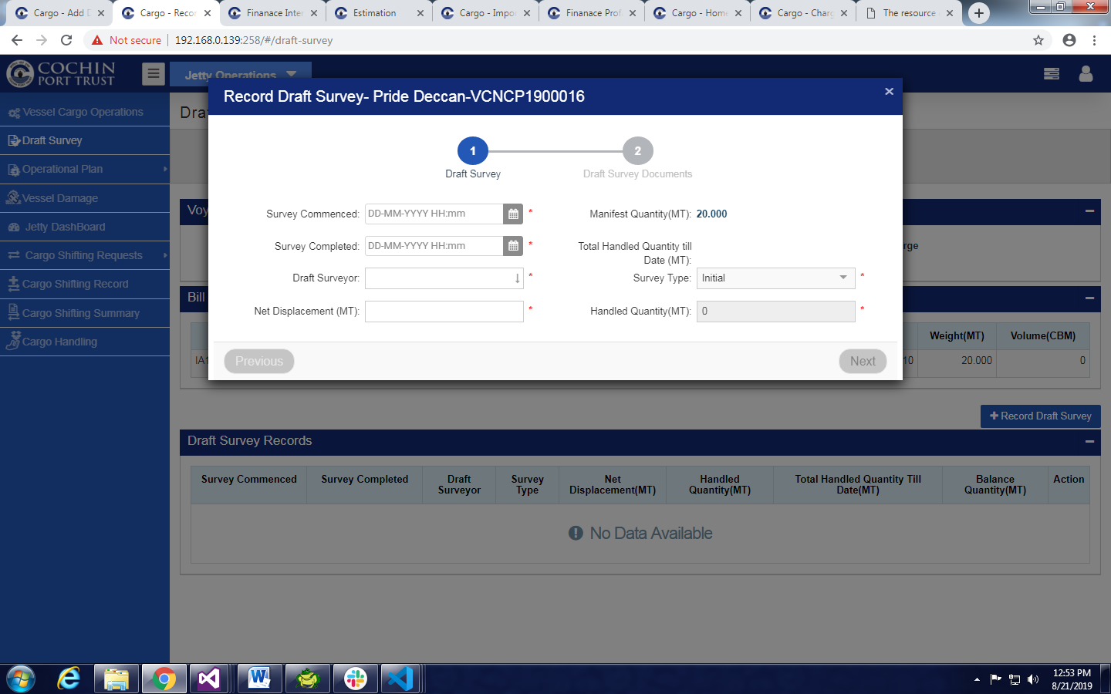

* Click on Save& Exit Button.
* Click on Record Draft Survey button.
* Give Valid Data
* Select Survey Type As Final
* Click on Next
* Click on Save& Exit Button.

1. To view Wharfage (Final) Invoice Open Finance Module.

* Click on Invoice .
* Invoice List Will Display.
* Filter with VCN Number or Application Dropdown menu and Application Module.
* Click On View Final Invoice Will Display.

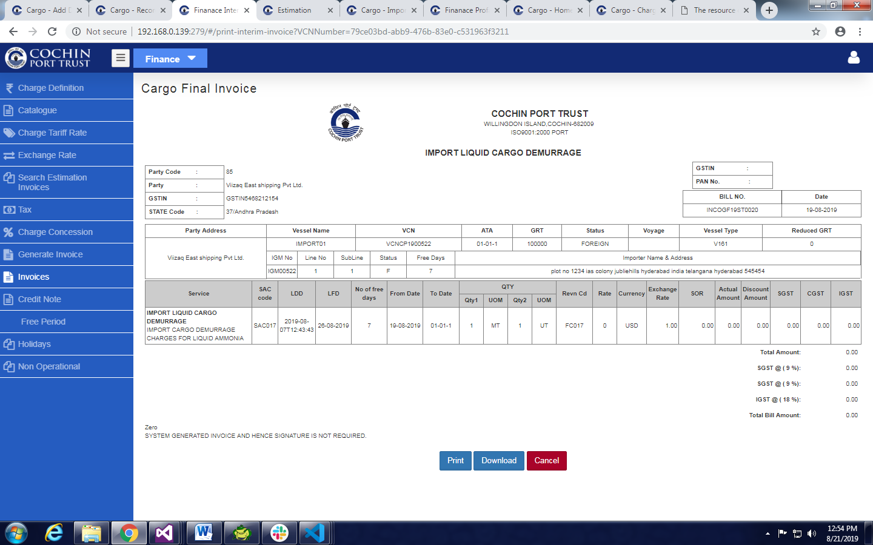

**Demurrage Invoice Steps**

1. Create Import General Manifest

* Provide Valid Data and click on Save.

1. Click on Agent Delivery Order.

* Click on Add Agent Delivery Order.
* Select VCN Number From Auto fill Suggestion.
* Give Mandatory Data.

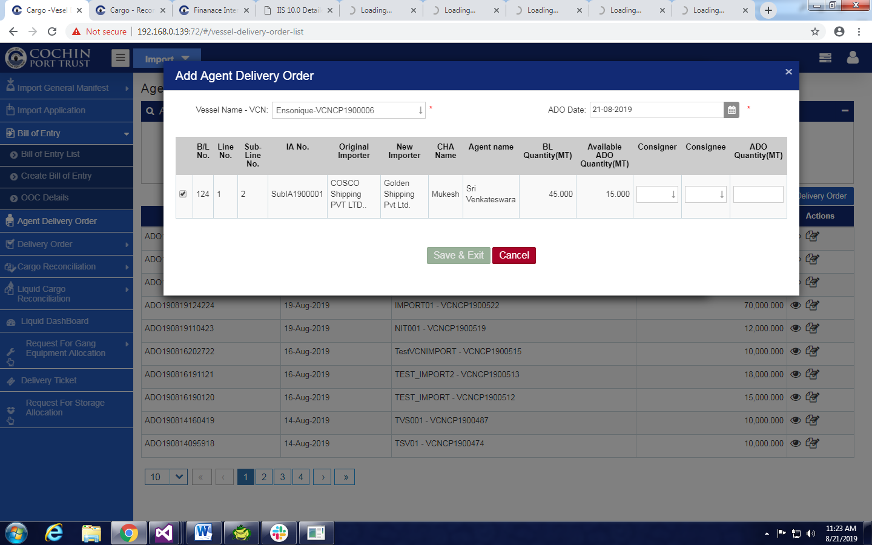

* Click on Save & Exit.

1. Click Create Bill Of Entry Under Bill of Entry .

* Select VCN Number From Auto fill Suggestion.
* Click On Record BE in Actions .

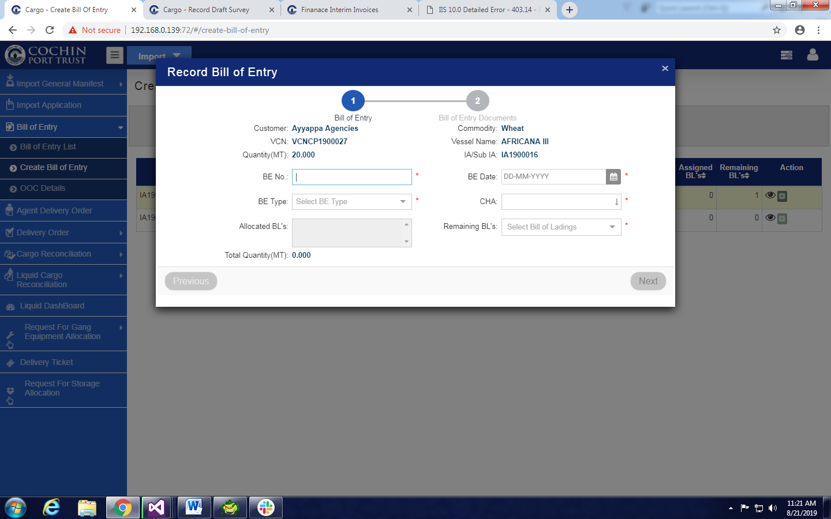

1. Click on OOC Details

* Give Valid mandatory Data
* Click On Save

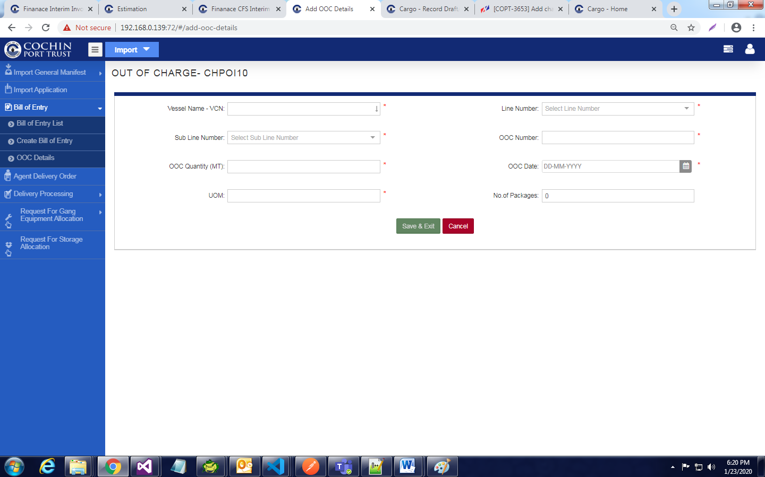

1. Click On Request For Storage Allocation

* Select VCN Number From Auto fill Suggestion
* Select IA Number from Drop down menu.
* Click On Record Request For Storage Location
* Give Valid mandatory Data
* Click on Save

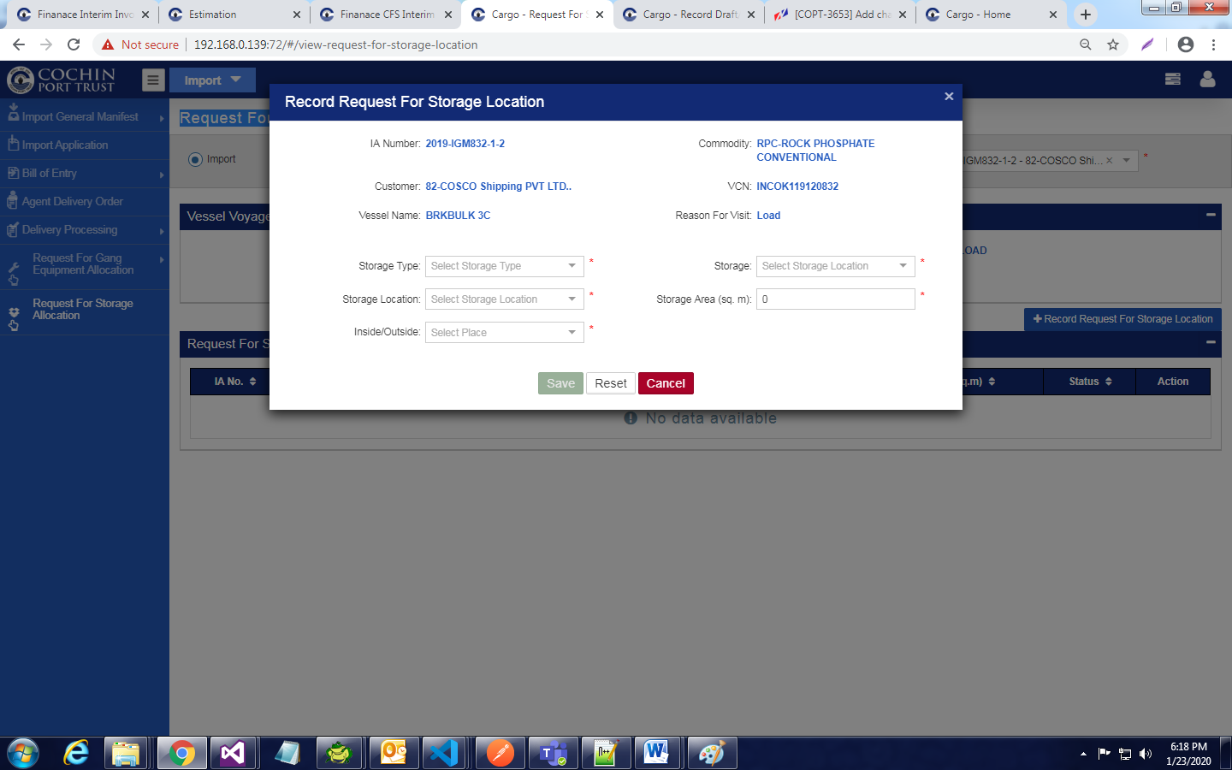

1. GO To YARD Operations Module

* Find Notifications And Give Approve

1. Go to IMPORT

* Go to Import Application
* Click On Allocate Storage Location
* Give Mandatory Data
* Click on save

1. Go to Yard Module

* Click On **Record Shore to Storage Movement**
* **Provide Valid Data**
* **Click On Save**

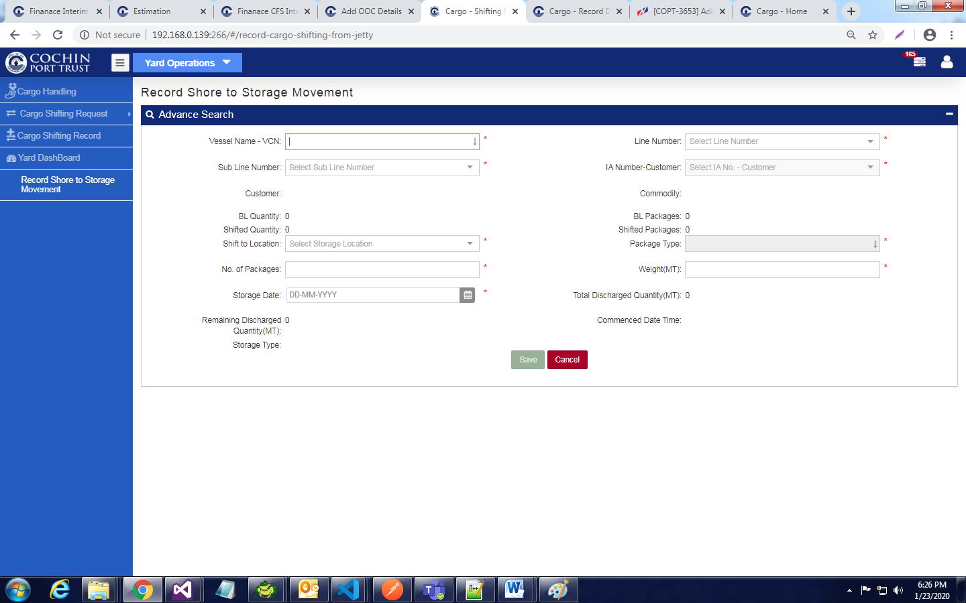

1. Click on Add Delivery Order under Delivery Order(IMPORT MODULE)

* Select VCN Number From Auto fill Suggestion .
* Select IA Number from Drop down menu.
* Give Valid mandatory Data

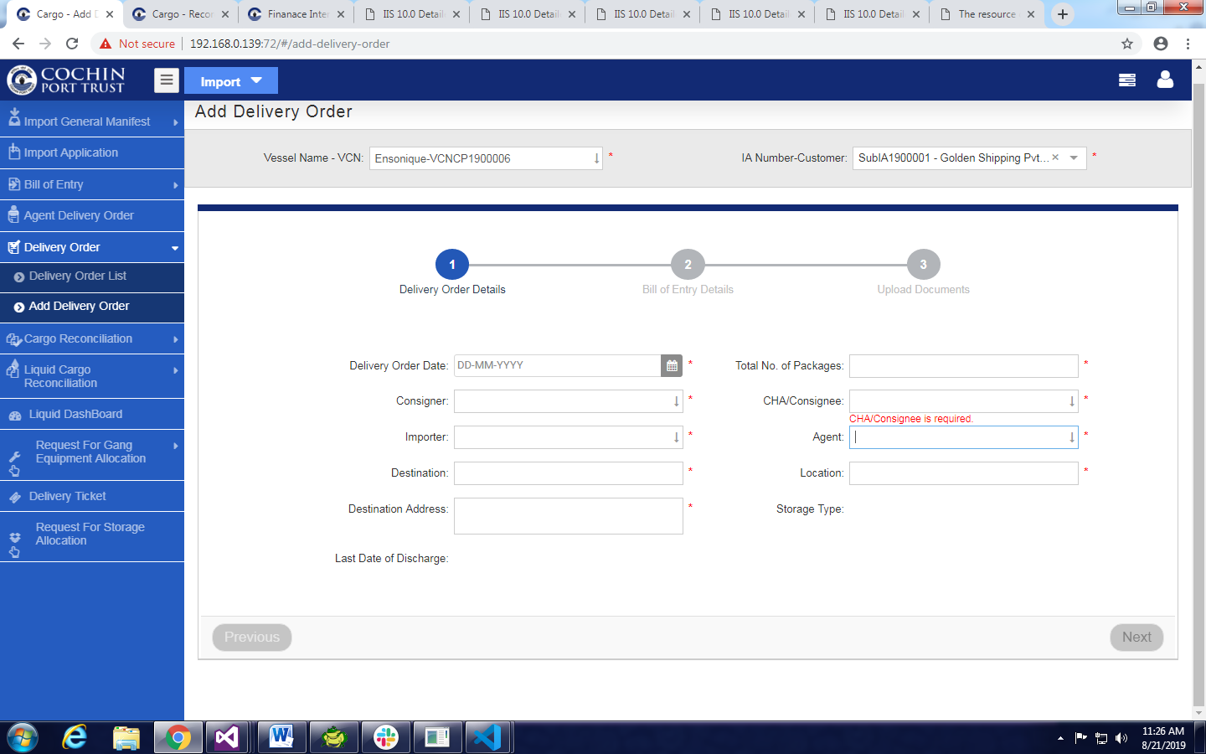

* Click on next
* Provide mandatory data under bill of Entry tab
* Click on next
* Click on Save & Exit button.

1. To view Invoice Click on Delivery Process list

* Click On Demurrage Invoice Icon
* And Generate Invoice From Here

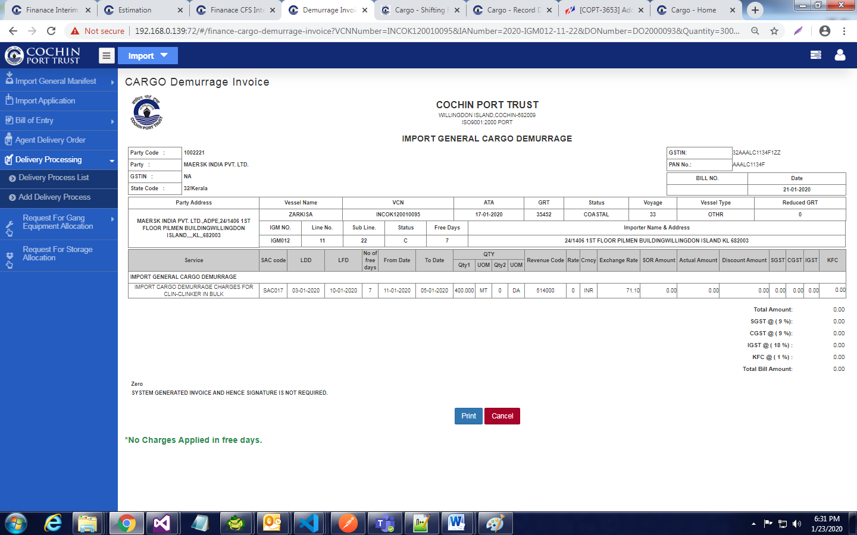

1. For Multiple cargo Handlings

* Open Delivery Process list
* Add truck Against DO Number

1. Open **Gate Module**

* Click On Gate In link
* Give Mandatory data
* Click on Permit Button

1. Open **Warehouse or Yard Operations Module**
2. Click on Cargo Handling.

* Click on Import Radio Button
* Select VCN Number From Auto fill Suggestion .
* Select Line Number and Sub Line Number
* Select IA Number from Drop down menu.
* Click on Record Cargo Handling Button

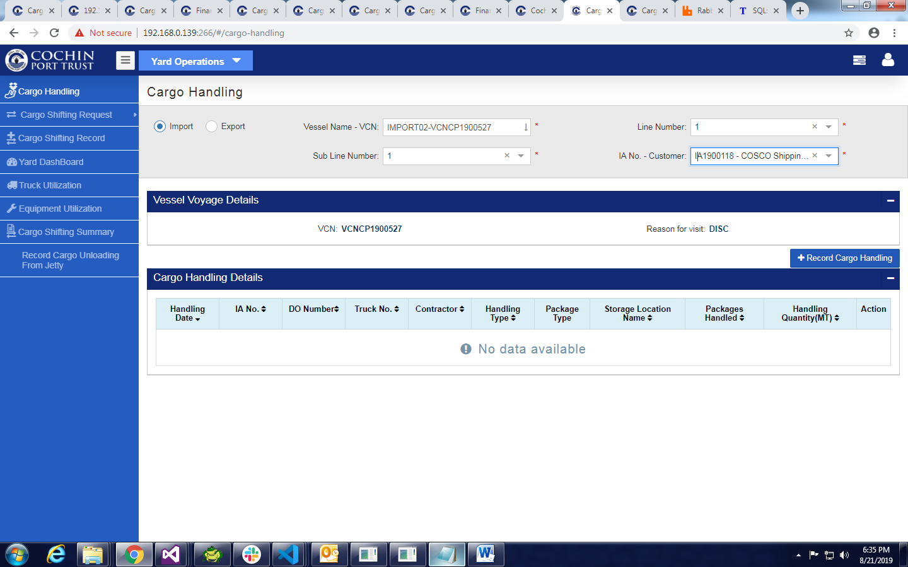

* Provide mandatory data
* Click on save Button

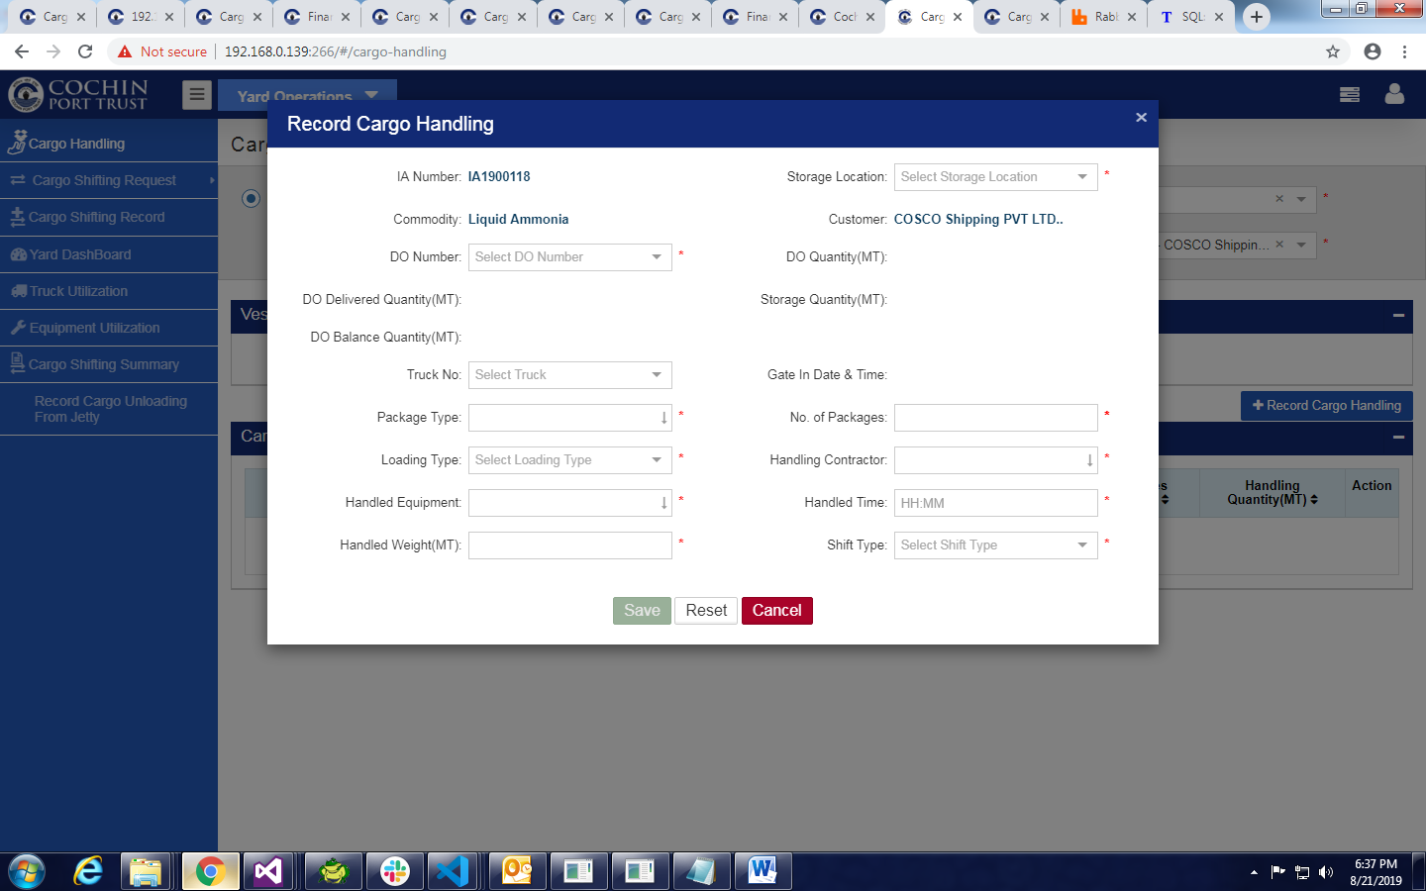

1. Open Import Module
2. Click on Delivery Order List under Delivery Order

* Click on Demurrage Invoice Icon in Actions

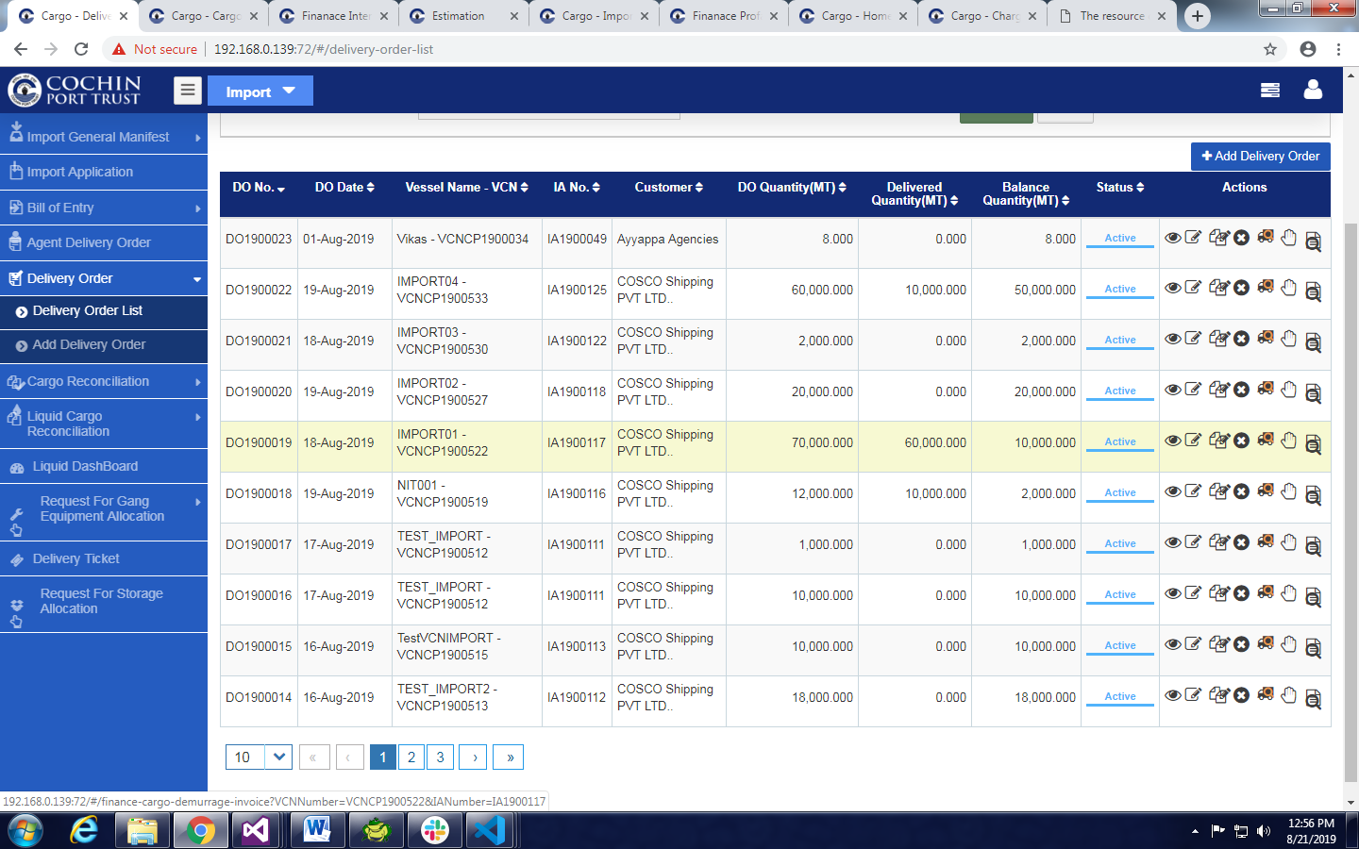

* Demurrage Invoice Will display .
* Click on Generate Invoice Button.
* To view Demurrage Invoice Click on Demurrage Invoice icon from Delivery order List.

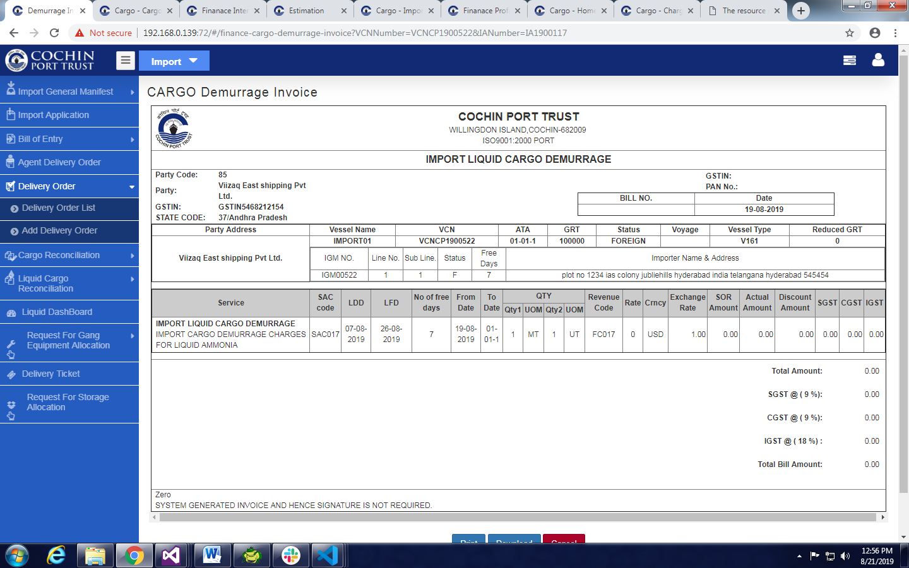

1. To view Invoices Goto Billing Module
2. Click On Invoice Screen
3. Search With Available Filters
4. Click On View
5. Invoice Will Display.